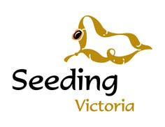
Seed Order Form
ABN: 96 122 519 419

Seeding Victoria
PO Box 3,Creswick, Vic, 3363
Phone: (03) 5345 2200
Email: info@seedbank.com.au

SEED ORDER FORM

Date
Business Name
ABN
Postal Address
Contact person
Telephone
Mobile
Email Address
Purchase Order No
Site details

ORDER

Batch No | Botanical Name | Provenance | Grams

All orders are posted unless otherwise requested.

Note: Sometimes seed batches may be no longer available. Do you wish us to substitute the same species from nearest provenance? (please tick) Yes ☐ No ☐

