  Ballarat Region Seed Bank  Phone: (03) 5345 2200 Fax: (03) 5345 2795  PO Box 3, Creswick, Vic 3363  Native Seed Collection Field Data Sheet  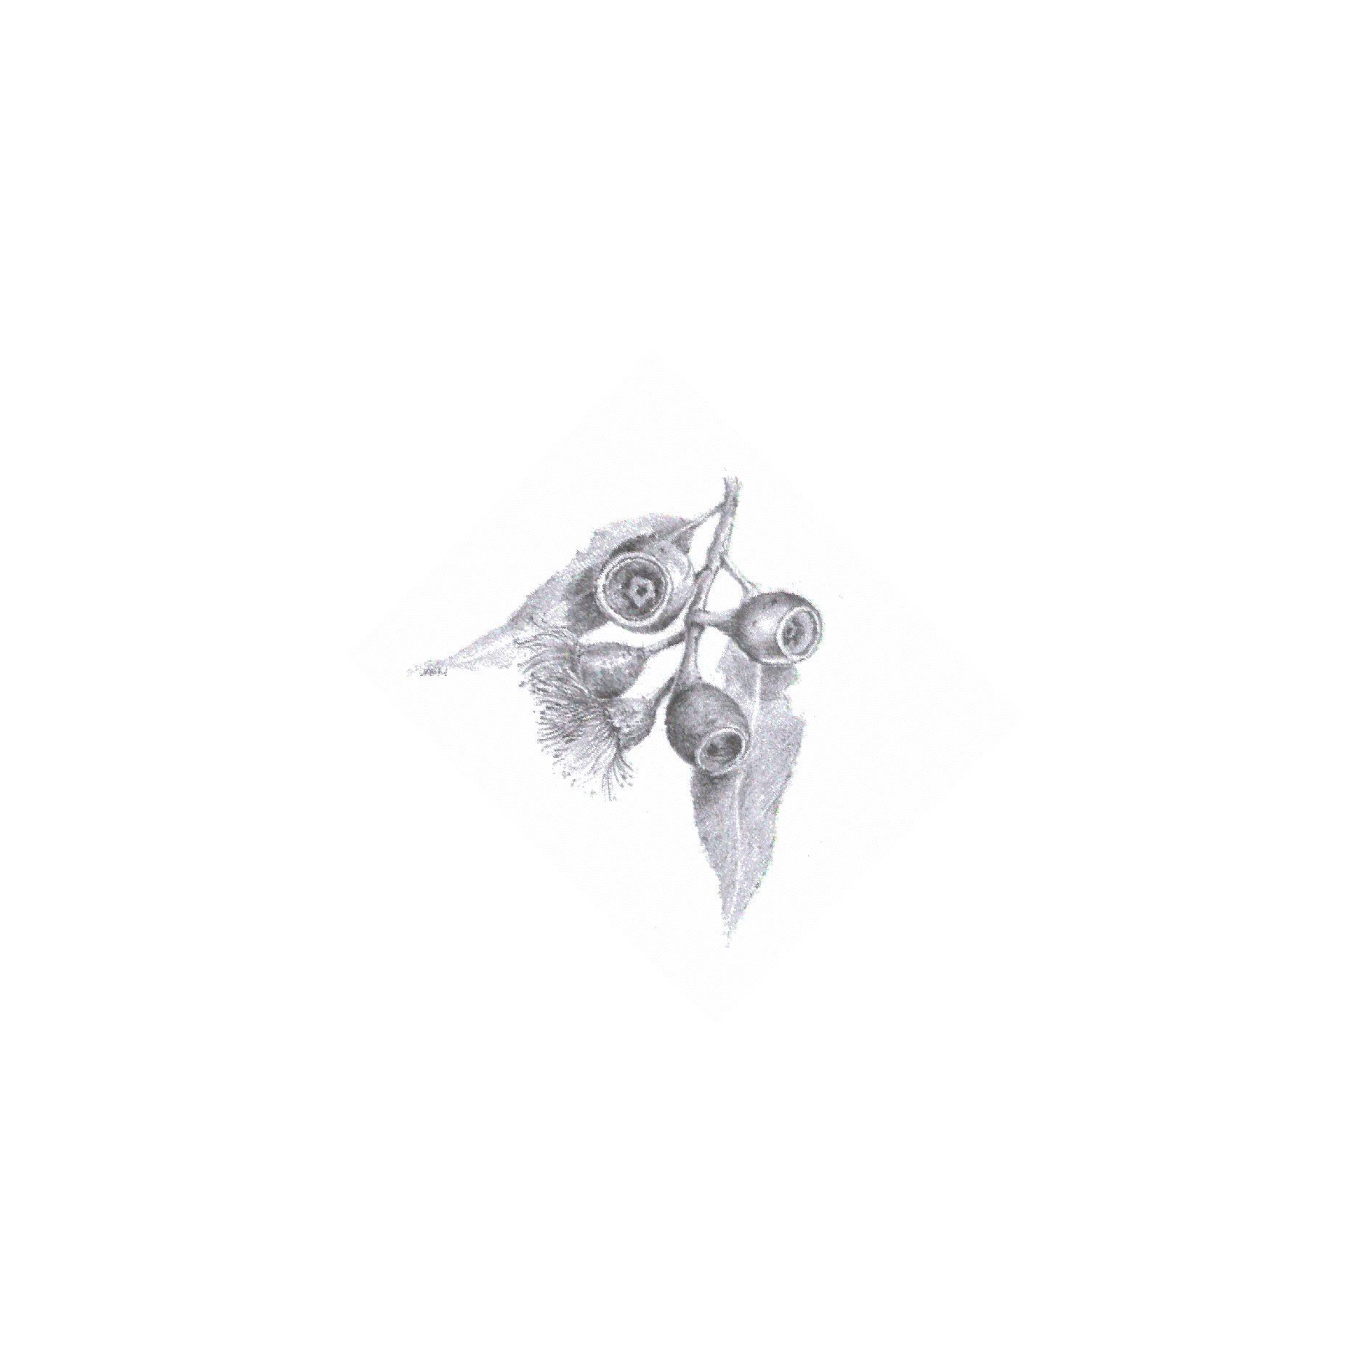 |  |  | Quantity (grams): |  | BRSB Batch Number: office use only  PAGE 1.
Genus: |  |  |  |  | Date collected:  ………day ………month ………year
Species: |  |  |  |  | GPS or Other Map and grid ref:
Location/Town: |  |  |  | or Latitude:  …………….º ……………’ ……………” South
Site Name: |  |  |  | Longitude:  …………….º ……………’ ……………” East
Tenure: please circle Roadside Private Land Public Land

State Forest Reserve Waterway Unknown Other ……………………………..

Population type: please circle  Remnant/Wild or Planted BRSB Registration no. ……………………...  Planted unregistered PTO & enter further details |  |  |  |  |  | Vegetation community (eg BVT or EVC):
Plant form: please circle  Tree Shrub Understorey Sedge Grass Other …………… |  |  |  |  |  | Plant Specimen taken?  please circle YES NO
No. of Plants Collected from? please circle  1-10 …………………………. Enter number  11-25 26-50 50-100 100+ |  |  | Population Size: please circle  1-10 …………………………Enter number  11-50 51-100 101-500 500+
Aspect: please circle  N NE E SE S SW W NW |  | Position on slope: please circle  Watercourse Flat Lower Slope Upper Slope Crest Dune
Geology: |  |  |  |  |  |  | Soil pH:
Surface Soil description:  Colour ……………………………. Type: …………………………………………… |  |  |  |  |  |  | please circle  SAND  CLAY LOAM
Collector Name: |  |  |  | Permit Number:
Project or Allotment: if known |  |  |  | Signature:
OFFICE USE ONLY
Date Received: |  |  |  | Seed quality:
Owner:
Buy in Cost/kg: |  |  |  | Selling Cost/kg:
Container Type: |  |  |  | Comments:  omment
Data Entry – SSS (date)

PAGE 2.
Ballarat Region Seed Bank  Seed Production Area,  Revegetation Site or Plantation  Original Seed Source Information  To ensure the integrity of seed supplied to Ballarat Region Seed Bank and consequently our clients and revegetation programs, seed from Seed Production Areas (SPA), revegetation sites or plantations requires additional information. We need to know about the original seed source used in its establishment. We require you to fill out the details below.  In order to simplify this process we are able to register SPA and revegetation sites for you to simplify this process. Please contact us for further details. |  |  |  | BRSB site registration no.:
 |  |  |  | Original batch no. (BRSB No. if applicable):
Date site established:

………day ………month ………year
Original seed source collection name location/town: |  |  | or Latitude:  …………….º ……………’ ……………” South
Original seed source collection site: |  |  | Longitude:  …………….º ……………’ ……………” East
Original tenure: please circle Roadside Private Land Public Land

State Forest Reserve Waterway Unknown Other ……………………………..

Original vegetation community (eg BVT or EVC) :

Plant form: please circle

Tree Shrub Understorey Sedge Grass Other ……………

No. of Plants Collected from? please circle  1-10 …………………………. Enter number  11-25 26-50 50-100 100+ |  | Population Size: please circle  1-10 …………………………. Enter number  11-50 51-100 101-500 500+
Geology:
Other information:

Please remember: the required information relates to the original seed source used for establishment of your site….

